Environmental impact assessment
This environmental impact assessment will measure the project in terms of mass of carbon released into the atmosphere.
For this I will consider:
-The energy used by servers for cloud computing on google colab
-The energy used by my laptop for the duration of this project
-The energy cost from querying ChatGPT throughout

I will assume this project has taken ~20 hours to complete using google colab
15 of these hours were spent using google colabs free CPUs which are Intel Xeon CPU with 2 vCPUs (virtual CPUs) and 13GB of RAM¹. The other 5 (this is an over estimation) were spent using google colabs GPUs NVIDIA Tesla T4 GPU with 16GB of VRAM¹.
Inputting this information into a cloud computing emission calculator², with the information that we are in Europe-west2³ which is considered a low carbon intensity zone for cloud computing.
The 15 hours of CPU time released: 47.92g of CO₂
The 5 hours of GPU time released: 98.31g of CO₂
So together the total cost of using google colab for cloud computing was 146.23 g of CO₂.

The total energy cost from using my laptop over this period was calculated with a battery report retrieved from this bash script: powercfg /batteryreport
This gave me information regarding the duration of use and the rate at which the battery drained as can be seen here: 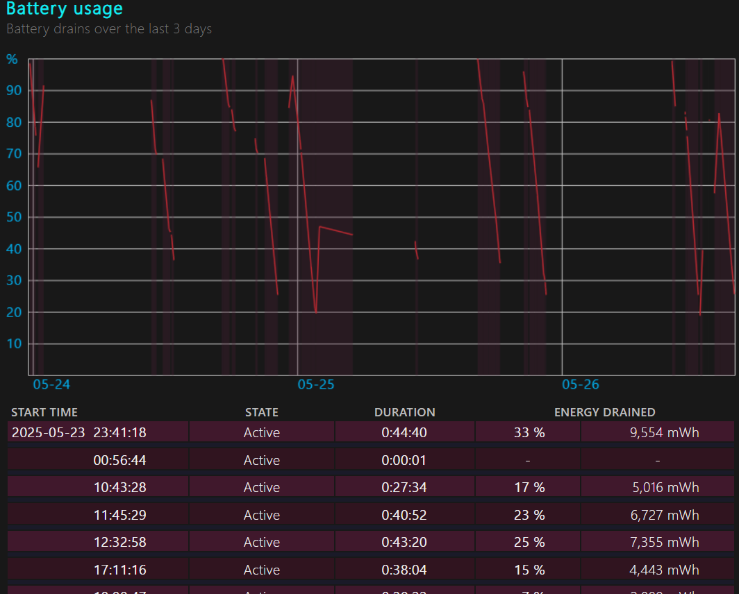
By averaging 5 of these, I was able to calculate that I would have used 13.13 watts over 20 hours of use. My home electricity supplier is EDF, who claim to have a carbon density of 136g of CO₂ per kilowatt hour⁴. This works out to 35.6g of CO₂ being released over this 20 hour period.
Finally, the cost of querying ChatGPT is 4.32 g of CO₂ per message⁵, as I didn’t track the exact number of queries made, I can only estimate, but this number would be in the hundreds.
An estimate of ~250 queries has a corresponding CO₂ mass of 1080g or 1.08 kg, which dwarfs other sources. Whilst a much smaller relative cost, I do say please and thank you to ChatGPT which allegedly increases required computing power⁶.
This puts the total environmental cost (of carbon released) at:
146.23g + 35.6g + 1080g = 1261.83g = 1.26kg of CO₂ that has been released because of this project.
As I am a vegetarian (and always have been) I have a carbon footprint of ~4 lbs less CO₂ emitted every day when compared to “medium meat eaters”. Over 20 days this works out to 36287.4g or~36kg less CO₂ emitted than an average meat eater.

¹https://saturncloud.io/blog/whats-the-hardware-spec-for-google-colaboratory/
²https://calculator.green-algorithms.org/
³https://cloud.google.com/sustainability/region-carbon#region-picker
⁴https://www.edfenergy.com/fuel-mix
⁵https://piktochart.com/blog/carbon-footprint-of-chatgpt/
⁶https://futurism.com/altman-please-thanks-chatgpt
⁷https://www.vox.com/2014/7/2/5865109/study-going-vegetarian-could-cut-your-food-carbon-footprint-in-half

